Imaging Center Workflow Reviews

Order Intake (Out-of-network referrals - eFax)
- Faxes will come into eFax folder in eCW
- Orders is sent to AbbaDox via HL7 from eCW.
- AbbaDox Creates a Pending Appointment

Order Intake (In-network Referrals) (Unique)
- Order is placed by an in-network physician in eCW.
- Order will not be sent to AbbaDox, order remains in eCW.
- These orders are scheduled by patient calling MANA
- Staff will answer phone and reference eCW to find order.
- While viewing order in eCW, user will create brand new appointment in AbbaDox.

Foreign Films - Order Intake, Management, Distribution (OncoEMR (HOG))
- Imaging Center Foreign Films team (Brittany) goes into OnceEMR the night before and identify the orders that have been placed in OncoEMR.
- User open AbbaDox and creates Pending Appointment under:
  - Pending Reason: Foreign Film
  - Location: Must be a Foreign Film location (HOG, Karas, among others)
    - 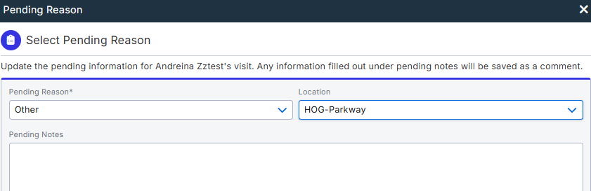
  - Action:
    - AbbaDox to create Accession and sends ORM to Merge PACS
      - Note: this is an exception to the rule where AbbaDox typically only creates accession for Schedule appointments.
- Order is sent into PACS and then Modality worklist.
- During TOS, the Tech at HOG selects the previously created order from MWL and drops images.
- Results are read in PowerScribe and ORU is sent to AbbaDox.
- AbbaDox will update the Appointment from Status Pending to Completed.
  - Action: AbbaDox to update via interface the order from Pending to Completed.
- Upon dictation, an “Unsolicited result” is sent to OncoEMR via the OB unidirectional interface.
  - Action: Referrings in AbbaDox should had distribution preference of Unsolocited turned on for AbbaDox to send via the OncoEMR interfaces. Otherwise, distribute via Fax.
    - 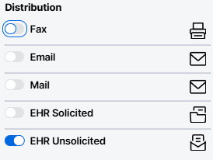
  - Action: Also, results performed for the HOG locations should have “hold” of 7-days before distribution to eCW.
- Note: AbbaDox cannot build a bidirectional interface with OnceEMR because eCW is the source of truth.
- Note: OB ORU is unsolicited to OncoEMR and eCW.
- Note: Specific referrings must receive the result with a delay of 7 days, therefore hold on ORU to eCW.
  - Reason: Oncologist (OncoEMR) should see report prior to patient seeing report in eCW patient portal.
  - Action: AbbaDox to create Generic List of Values of Referrals that need hold on distribution to eCW.
    - Once GLV is available, enable in settings for Dawn and Brittany.
- Note: To review cancels, user would filter to:
  - Created On: Yesterday or Today
  - Pending Reason: Foreign Film
  - Select cancel appointment.

Pending Appointments
- AbbaDox can have Pending Appointment worklists that filter modality
  - Actions: Create worklist for Imaging Center Order and Breast Center Orders
    - Filter each worklist to modalities accordingly.
  - Actions: Create worklist called Imaging Center Missing Auth
    - Actions: Worklist should be mapped to MR, CT, US
    - Actions: In HL7, should Auth not be available, assign the Pending Authorization
  - Issue: Pane View not visible.
  - Action: Create Pending Reasons for:
    - To Be Scheduled for 2nd attempt
    - To Be Scheduled for 3rd attempt
    - Unable to Scheduled Contact Referring
    - Add filter for Last Modified On, Apply Yesterdays’s DOS
- Flags and Special Needs
  - AbbaDox to create same flags as in Merge, but as Special needs.
  - During migration, AbbaDox should map to flag.
  - Action: Dawn to share flags, MANA – Complete – Sent to Ruben
  - Action: AbbaDox to create Flags as special needs and map during migration.
- Deceased
  - On ADT interface, if appointment is updated to deceased in AbbaDox create a tasks.
    - Action: Create Patient Deceased Task.
      - Apply logic that creates task when patient is deceased.

Scheduling
- Wizard will be the same for both centers.
- Action: Do not send order to Merge PACS upon New Status, send it upon Checkin.

Pre-registration
- Eligibility team (Goes first): Checking to make sure insurance is valid.
  - In AbbaDox, user could work from Eligibility Worklist.
  - Once insurance is confirmed as Eligibile, user can update to:
    - Insurance Reviewed: Eligible
      - Action: Create option in Dropdown
    - Verification Status: Auth Required
      - Action: Create option in Dropdown
- Authorization team (Goes Second): Checks for the Authorization
  - Authorization prints out for two weeks in advanced.
  - In AbbaDox, user could work from Pre Auth worklist.
  - Pre Auth Worklist would be filtered to:
    - Insurance Reviewed: Eligible
    - Modality: MRI, CT, and US
      - Caveat: US would display all procedures
    - User can user Verification Status filter to apply Status to Auth.
      - Action: Need to clean update Verification status dropdown
  - Note: Imaging Center receives orders from eCW and from Outside Referrals
    - The eCW order do not have Auth, therefore team must always check.
    - The Outside Referrals, however, always have an auth with order.
      - In such case, the eligibility will mark appointment as Outside Referral
      - Action: Pre-auth worklist should only by mapped to Verification Status: Auth Required

Registration
- All Xray are walk-ins.
- Patient walks-in and signs the name in clipboard.
- Status updates from Scheduled to Checked In once all documents are signed.
  - Action: Order is sent to PACS update status update to Checked In.
- ID Card Scanning
  - ID card and insurance are scanned into eCW, not Merge RIS.
- TOS Payments
  - eCW owned process
  - MRI – Payment collected prior to procedure
  - All Other Modalities – collected after
  - Moving away from Frezure and into Collectitly.
  - Amount collected in TOS system does not get sent to RIS.
- Document Management
  - Router document is printed at time of registration.
    - Contains all patient document demographics, visit comments, insurance.
    - MRI – Prints document the night before.
  - Once document is signed, it is scanned back into eCW, it does not go into RIS.
- *** ON NEXT CALL, AbbaDox will Discuss document management Solution with MANA***

Technologist

